COUNTRY

CONTACT PERSON

EMAIL

TEL NUMBER

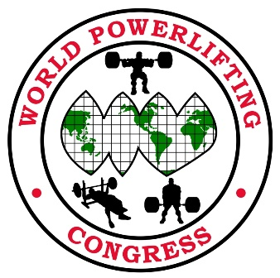
2016 WPC World Championships
7-13 November
Crowne Plaza, 4728 Crowne Ave, Baton Rouge, Louisiana 1-225-925-2244

COMPETITOR’S NAME | POWERLIFTING (PL)  BENCH (BP)  DEADLIFT (DL) | MULTI PLY (MP)  SINGLE PLY (SP)  CLASSIC RAW (CR)  RAW (R) | WEIGHT  CLASS | DOB + AGE |  | Open Teen Junior Master | FEE
 |  |  |  |  | TOTAL FEE

COMPETITOR’S NAME | POWERLIFTING (PL)  BENCH (BP)  DEADLIFT (DL) | MULTI PLY (MP)  SINGLE PLY (SP)  CLASSIC RAW (CR)  RAW (R) | WEIGHT  CLASS | DOB + AGE |  | Open Teen Junior Master | FEE
 |  |  |  |  | TOTAL FEE

