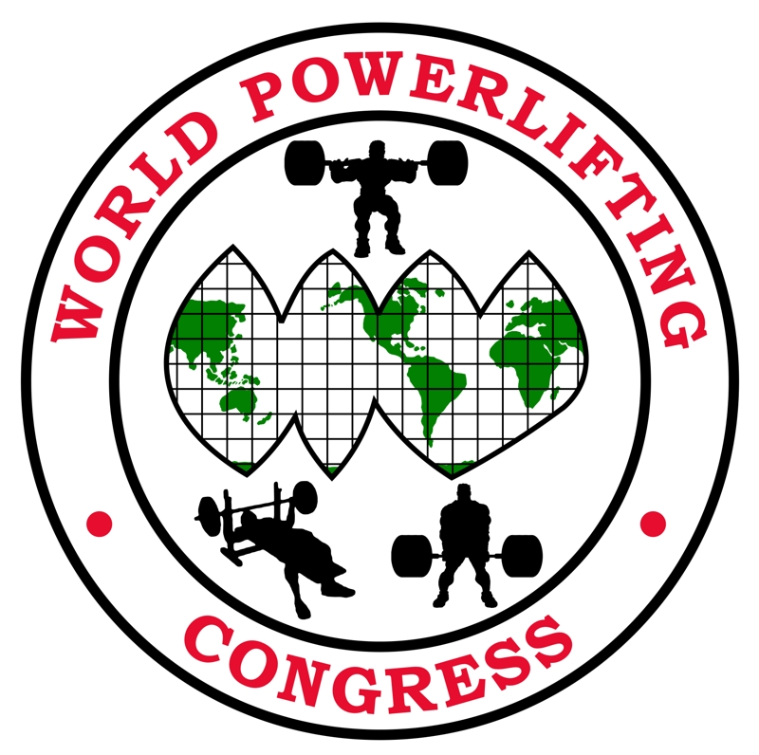
Dear Friends,
It is my pleasure to announce the date and location for the 2017 AWPC-WPC World Cup. The date is August 31- September 2, 2017 in Idaho Falls, Idaho, USA. We look forward to seeing a Team from your country represented. If your country is not an affiliate of the WPC/AWPC please contact us to join!
Q & A Seminar by Bruce McCord & Gordon Santee 7:00 pm Thursday August 31
Entry Form - Please have each athlete fill out all details on the entry form.
Entry Deadline- July 1, 2017 Entries must be received by this date.
Entry Confirmation - Please notify the meet promoters regarding your countries attendance as soon as possible. You may notify us by e-mail snakeriverpl@cs.com or phone us at 208-528-0444.
Entry Fee- $100.00 Crossover or additional division $50 (US Dollars)
An entry fee is required for each division. The first division is $100 and the second division is $50. Please send all entries in one packet. Make checks payable to: Snake River Powerlifting
Mail to: Snake River Powerlifting, PO Box 51433, Idaho Falls, Idaho, USA 83405 or contact Linda Higgins at 1-208-528-0444 to make arrangements via bank transfer or Western Union.
Hotel Reservations - Meet Hotel and Venue: Hilton Garden Inn Idaho Falls, ID, 700 Lindsay Blvd , Idaho Falls, Idaho 83402 United States Tel: 2085229500 Fax: 2085229501
A block of rooms have been reserved for August 29, 2017 - September 7, 2017. The special room rate will be available until August 14th or until the group block is sold-out, whichever comes first. The rate posted is $109.00 w/ breakfast for 2. In the comment box online request the breakfast rate.
Also we are going to extend the rate if you would like to spend a few extra days and go to Yellowstone National Park which is 1 hour and 30 minutes away or go to Jackson Hole Wyoming which is 1 hour away.
Booking a reservation from our site is simple. To begin the process, click on "Book a Room" below to receive your group's preferred rate. http://hiltongardeninn.hilton.com/en/gi/groups/personalized/I/IDAIFGI-GPW-20170827/index.jhtml
See you at the Hilton Garden Inn Idaho Falls in September! We hope you enjoy your stay and your group's event!
At the Hilton Garden Inn, you'll find everything you need including complimentary high-speed Internet and remote printing provided by PrinterOn® in all guestrooms and lobby areas. The Hilton Garden Inn - Idaho Falls, Idaho hotel is certain to please the busy executive or leisure traveler. Our Hilton Garden Inn Idaho Falls hotel is just minutes away from downtown Idaho Falls and within walking distance of several fine restaurants and shops.
Meet Directors: Linda Higgins & Amy Jackson
FOR ALL INFORMATION CONTACT: Linda Higgins, PO Box 51433, Idaho Falls, ID 83405 1-208-528-0444 or snakeriverpl@cs.com Amy Jackson 1-630-896-7309 or amyljackson@aol.com

Lifting Schedule:
Thursday August 31 10:00 am Men Equipped MP (multi ply) SP (single ply) CR (classic raw full PL only)
Friday September 1 10:00 am All Teenage, Special Olympics & Youth All Women: Raw, MP, SP, CR all divisions
Saturday September 2 10:00 am Raw Male Open, Junior, Submaster, Master

Weigh-Ins:
Thursday Competitors: Wednesday August 30 10am-noon & 3pm-5pm
Friday Competitors: Thursday August 31 10am-noon & 3pm-5pm
Saturday Competitors: Friday September 1 10am-noon & 3pm-5pm

Weight Classes: Men 114, 123, 132, 148, 165, 181, 198, 220, 242, 275, 308, SHW
Kilos 52 56 60 67.5 75 82.5 90 100 110 125 140 140+
Women 97, 105, 114, 123, 132, 148, 165, 181, 198, UNL
Kilos 44 48 52 56 60 67.5 75 82.5 90 90+

Awards: Awards will be given to the first three places in each Men’s & Women’s divisions. There will be one Men and one Women best lifter award based upon content of entries in each division by formula.

Idaho Falls Visitor Bureau
Check out the following sites for information on tourist travels.

www.visitidahofalls.com

Jackson Hole Visitor Bureau –
www.jacksonholechamber.com

West Yellowstone Visitor Bureau –
www.destinationyellowstone.com

Yellowstone National Park –
www.yellowstone-natl-park.com/visit.htm

Sun Valley Idaho –
www.visitsunvalley.com

Chester’s Grand Teton Harley Davidson

10% off Rentals for Powerlifters ask for Brandee 1-208-523-1464

www.tetonharley.com

T-Shirt Logo

Back of shirt – WPC logo on front left chest

Make sure you pre order – limited availability at the meet

For special orders i.e. hoodies, etc. contact Linda Higgins

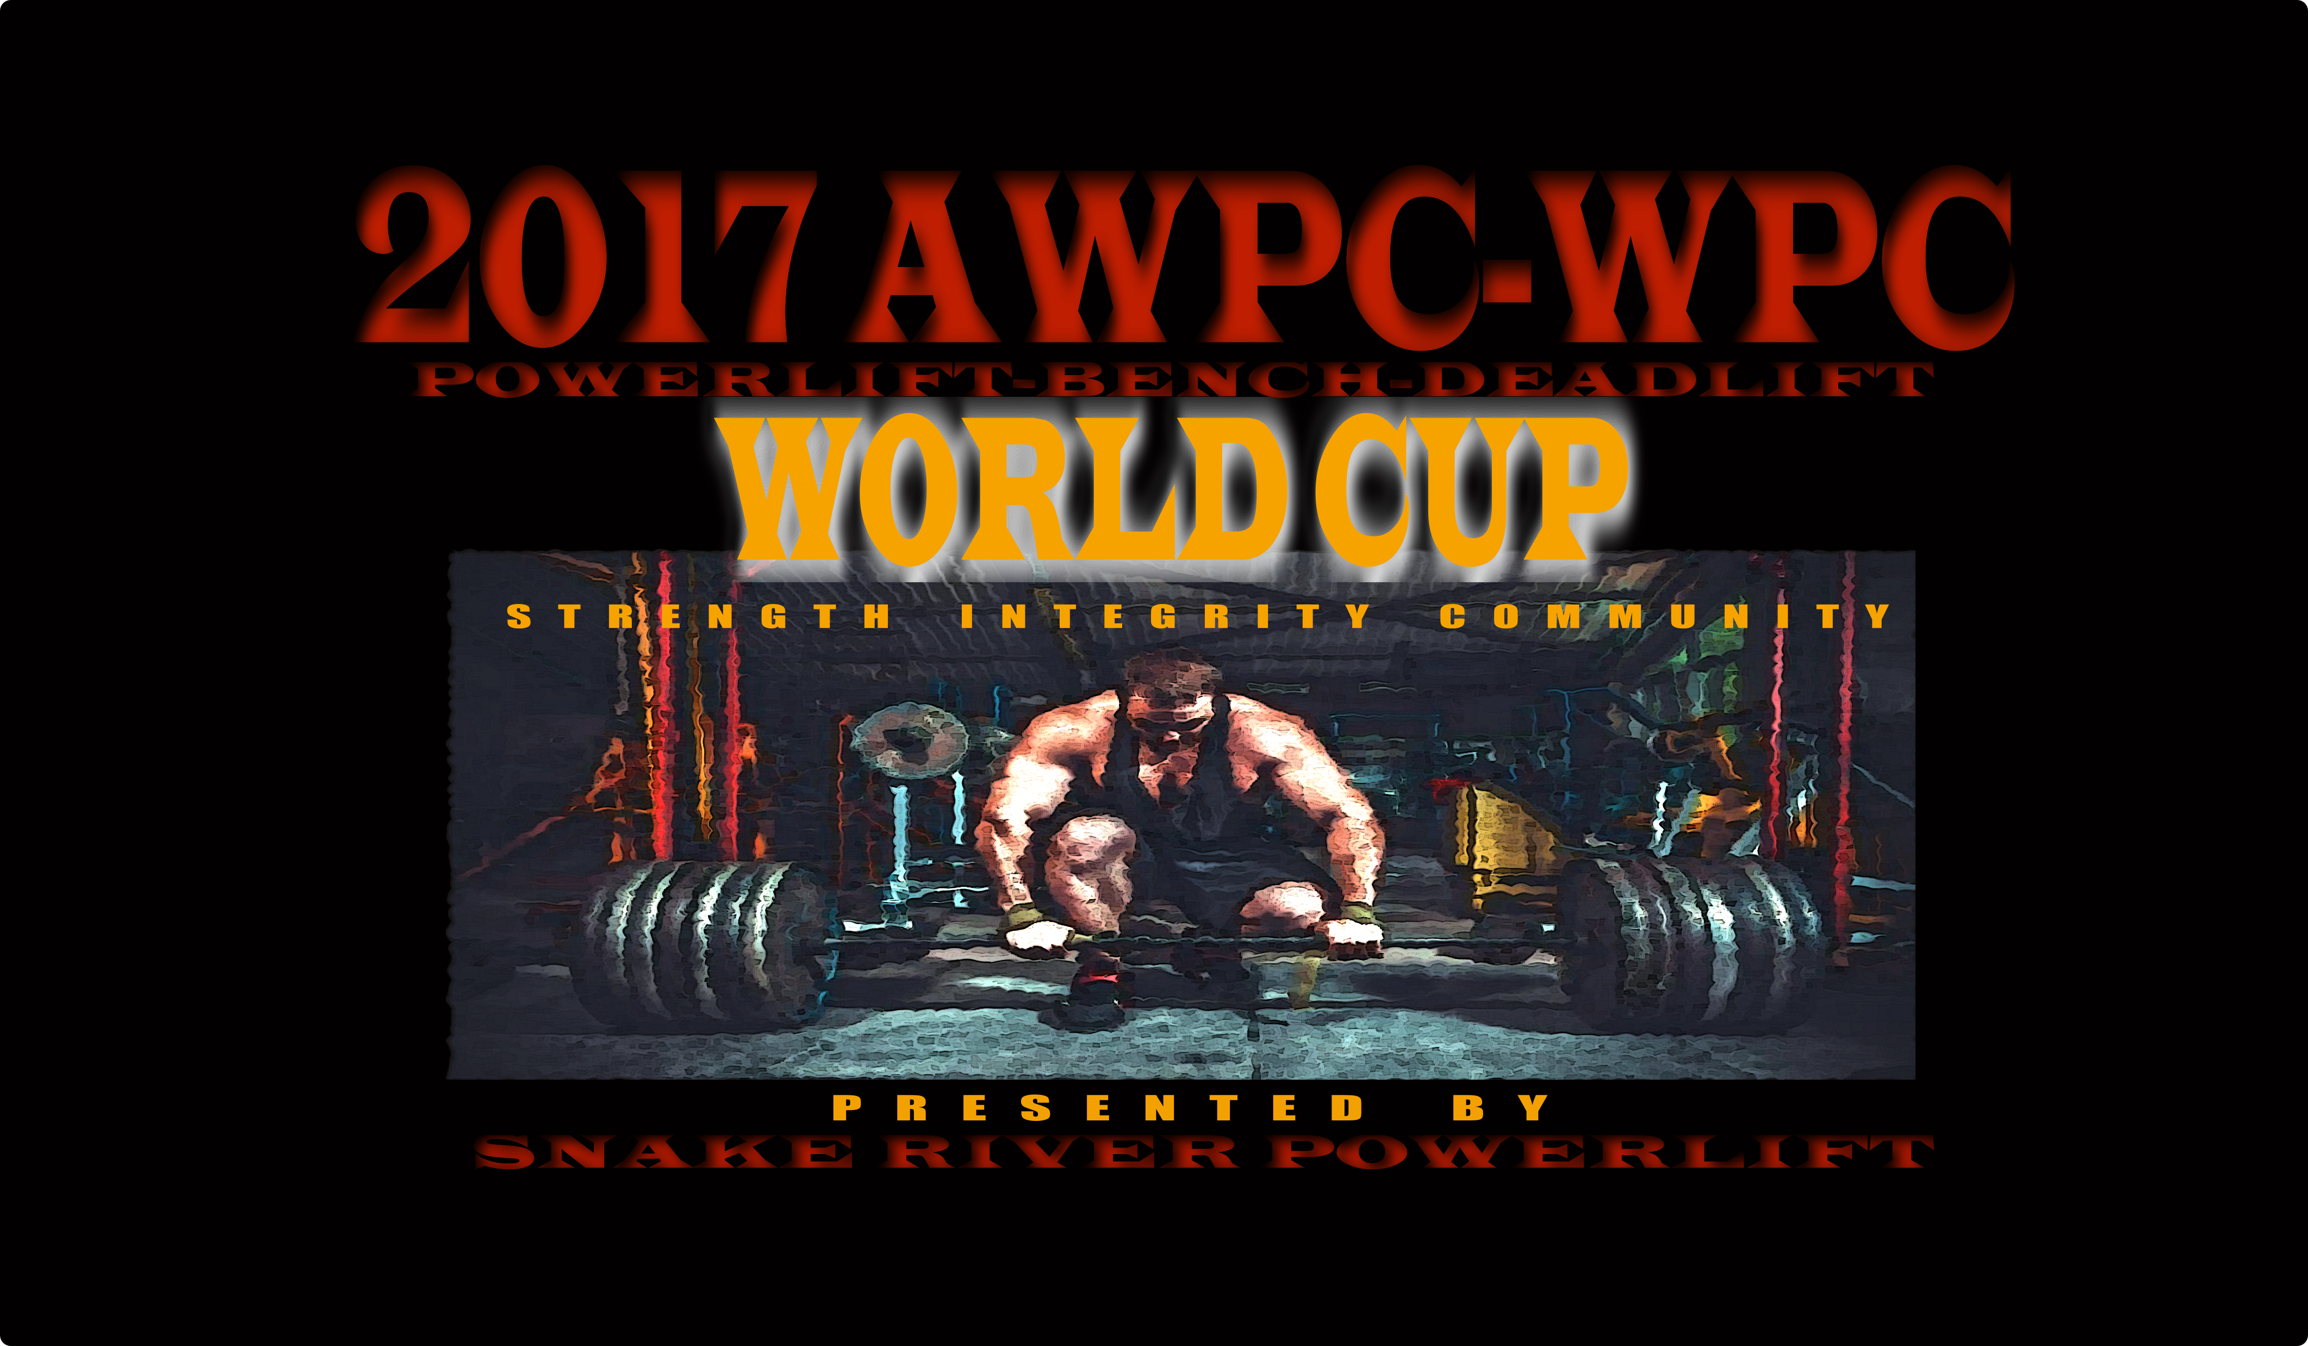

2017 AWPC-WPC World Cup
Q & A Seminar by Bruce McCord & Gordon Santee 7:00 pm Thursday August 31

Name_______________________________________________________________________________

Address_____________________________________________________________________________

City___________________________________State_________________Postal Code_______________

Country _______________________ Date of Birth________________________Age________________

Phone #___________________________________Cell#______________________________________

E-mail_______________________________________________________________________________

Weight Class: ________________________ Men□ Women□

Sanction (circle all that apply) WPC AWPC (drug tested)
Event Entered (circle all that apply): Full Meet Bench Only Deadlift Only
Raw/MP (multi ply) / SP (single ply): Raw MP (multi ply) SP (single ply) CR (classic raw full PL only)
Division Entered (circle all that apply): Open
Teen: 13-15 16-17 18-19
Junior: 20-23
Submaster: 33-39
Master: 40-44 45-49 50-54 55-59 60-64 65-69 70-74
75-79 80+
Police/Fire (AWPC Only) Special Olympics Youth (parent supervised)
WEIGHT CLASSES: Men 114, 123, 132, 148, 165, 181, 198, 220, 242, 275, 308, SHW Kilos 52 56 60 67.5 75 82.5 90 100 110 125 140 140+

Women 97, 105, 114, 123, 132, 148, 165, 181, 198, UNL
Kilos 44 48 52 56 60 67.5 75 82.5 90 90+

Raw (belt, singlet, wrist wraps) Single Ply (belt, knee & wrist wraps, singlet or single ply polyester squat suit (no velcro), single ply briefs not to extend 4” above top groin), bench shirt single ply polyester pullover (no Velcro or open back), Multi Ply, see www.worldpowerliftingcongress.com for complete rules Classic Raw (raw with knee wraps or knee sleeves)

Fees & Payment: Late Fee After 7/1/17 $ 30 $ ___________

Entry Fee $100 $___________

Additional division(s) $ 50 $___________
Special order hoodies, etc. contact Linda
Youth (parent supervised) $20 $___________

MEET T-SHIRTS: Pre-Order at $15.00 each Meet T-Shirt (s) $15 $___________
2X & 3X $20
$20 $___________
S____M_____L_____XL_____XXL_____XXX_____
(shirts available at the meet in the sizes above at $20 each) TOTAL DUE $_______________

I, THE UNDERSIGNED, AGREE TO WAIVE AND RELEASE ANY AND ALL RIGHTS FOR DAMAGES OR INJURIES OF ANY KIND SUFFERED BY ME IN ANY WAY DUE TO THIS CONTEST AGAINST Snake River Powerlifting, Linda Higgins, Amy Jackson, Hilton Garden Inn Idaho Falls, AWPC/WPC AND ANY AND ALL OFFICIALS, ITS STAFF AND ANYONE ASSOCIATED WITH 2017 AWPC-WPC World Cup.

ATHLETE’S SIGNATURE: (parent required if under 18)_______________________________________________________ DATE____________
Mail to: Linda Higgins, PO Bo 51433 Idaho Falls ID 83405

