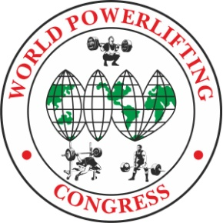

President WPC-RUSSIA Meet Director President WPC Kyrgyzstan
wpcwpo@gmail.com powerlifting_kg@mail.ru
Yuriy Ustinov
+7-918-947-04-62 Dmitriy Dorozhenko
+996755510433

WPC/AWPC OPEN EUROPEAN CHAMPIONSHIP- 2023
in POWERLIFTING, BENCH PRESS & DEADLIFT

Location: Bishkek, Kyrgyzstan.

Meet Director: Dmitriy Dorozhenko, WPC Kyrgyzstan President.

Dates: 21-25 ^{June} 2023
Lifting and
Weigh-In Schedule: 22 June. PL All Woman and PL RAW Men.
23 June. PL Men Classic and EQ (SP and MP).
24 June. BP and DL all Woman and Men.
25 June. All Nationals Power sports tournament.

Categories: All AWPC/WPC Weight Categories & All AWPC/WPC Age Divisions
Raw, Classic Raw, Single-ply and Multiply.

Entry Fees: First Event WPC $ or Euro 85
Additional Events S or Euro 45 per event

First Event AWPC $ or Euro 100
Additional Events $ or Euro 45 per event

Late Entry Fees – no penalty

Closing Date: 25th May 2022. Team List must reach the Meet Director by this date, otherwise late entry fees will apply. Each nation must set their own closing dates for lifters to submit their entry for inclusion on the team list.

To Enter: To apply, you must contact your WPC Country Head. If there is no one, then write
directly to the organizers: powerlifting_kg@mail.ru
There are no upfront fees. All payments are on the spot.

Websites: All information will be included on the championships website:

http://powertable.ru/api/hs/p/all_sorev?fed=0021&lg=en www.wpc.kg

Visas: Citizens of most countries of the world do not need a visa to Kyrgyzstan. But it is worth clarifying this about your country.

Hotel: Please contact Secretary Mrs. Gulzhana for details e-mail: nurlaeva2015@mail.ru
Airports nearby: Manas, Bishkek.

Rules: These Championships will be conducted using the AWPC/WPC Rules. The Rulebook is available to download from the WPC Website https://worldpowerliftingcongress.com/

Referees: Applications for refereeing from the referee of the international category WPC to the e-mail address are accepted: nurlaeva2015@mail.ru

Welcome to Kyrgyzstan.

