APF/AAPF 14th Annual Show of Strength
July 22, 2023

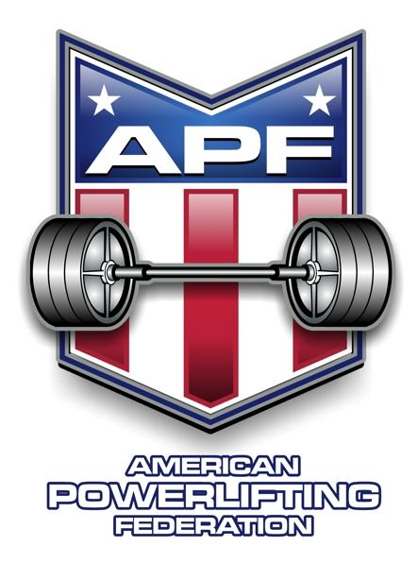

MEET DIRECTORS: Greg McCoy
Greg@hiddengym.net

STATE CHAIRS: Randy and Liz Nesuda (214) 517–9119; LNesuda@hotmail.com

SANCTIONED BY: APF

EVENT LOCATION: Hidden Gym
109 N Greenville Ave A
Allen, Texas 75002
Sign up online at: 14th Annual Show of Strength

ELIGIBILITY: Lifters must be an APF registered athlete by the time of the meet. You can renew or get your new membership online at World Powerlifting Congress. Memberships are sold online only at World Powerlifting Congress and will not be sold onsite.

WEIGH-IN: Friday, July 21, 2023: 9:00am – 1:00pm and 4:00pm – 6:00pm

Saturday, July 22, 2023: 7:00am – 8:00am

EVENT: MANDATORY RULES BRIEFING: Saturday July 22, 2023, at 8:00am
Lifting starts Saturday, July 22, 2023, at 9am

UNIFORM: One-piece lifting suit or wrestling suit is MANDATORY. APF/AAPF rules apply. AAPF requires 10% of competitors to be drug tested. Please review uniform rules at: World Powerlifting Congress.

CONTEST LIFTS: Full Meet (Squat/Bench/Deadlift), Bench Only, and Deadlift Only

QUALIFYING: Meet can be used to qualify for APF and/or AAPF Nationals.

ENTRY FEE: Meet entry fee is $100 if received on or prior to July 1, 2023. If received after July 1, 2023, there will be an additional $25 late fee. Additional divisions are $50 each. All entries are encouraged to be done online at 14th Annual Show of Strength. Or you can mail in the entry fee with Cash, Check, or Money Order to Hidden Gym, 109 N Greenville Ave Allen, Tx 75002. Cash or check accepted on the day of the event. Make checks payable to Hidden Gym.

SPECTATOR FEE $10

APF/AAPF 14th Annual Show of Strength
July 22, 2023

Please Print Legibly

Full name: ___________________________________________________________________ Sex (circle one): Male Female
Age ____________ Date of Birth ____________________________ e-mail ___________________________________________
Address ___________________________________________________________________________________________________
City ___________________________________________ State ___________________ Zip Code ___________________________
Phone Number ____________________________________ Alternate Phone Number _____________________________________
Current APF card (circle one): No Yes If so, card number is ____________________________________________________

APF/AAPF (circle one)
Event Entered (circle all that apply): Full Meet Bench Only Deadlift Only
Raw/Equipped (circle one): Classic Raw Raw Multi-Ply Equipped Single-Ply Equipped
(Note. Classic Raw is Raw with knee wraps or knee sleeves and must be full meet only – no single lift divisions)

Division Entered (circle all that apply): Open
Teen: 13-15 16-17 18-19
Junior: 20-23
Submaster: 33-39
Master: 40-44 45-49 50-54 55-59 60-64 65-69 70-74
75-79 80+
Weight Class (circle one): Women: 97 105 114 123 132 148 165 181 198 220 242 242+
Men: 114 123 132 148 165 181 198 220 242 275 308 308+

Fees & Payment: Entry fee $100: __________

Register Online at HiddenGym.net/SOS If after July 1, 2023, add late fee $25: __________
Or send Cash, Check, or Money Order
Additional divisions $50 each: __________
Make checks or money orders out to:
Hidden Gym
TOTAL DUE: __________

ATHLETIC RELEASE: On behalf of myself, my heirs, executors, administrators and assigns, I hereby waive, release and fully discharge any and all officials, sponsors, participants or organizations connected to the Texas APF/AAPF, Randy and Liz Nesuda, Greg and Tawna McCoy, and Hidden Gym from any and all rights, claims, demands, lawsuits, and causes of action due to or arising from any accident, injury, damage or loss directly, indirectly, or in any way associated with my participation in the APF/AAPF Show of Strength event on July 22nd, 2023. I also, represent that I know of no medical reason or condition that would impair my ability to participate in this event, and I hereby assume any and all risk of accidental, medical injury or consequential damages resulting from my participation. I acknowledge, understand and accept the inherent risk of powerlifting. I have read the above release, understand its meaning and consequence, and agree to be legally bound by its terms. I have signed this release freely and voluntarily.

___________________________________________ ____________________________________________
Print Full Name Lifter’s signature
(Parent must sign if Lifter is under 18 years of age)

Return Entry Form to: Hidden Gym
109 N Greenville Ave
Allen, Tx 75002

Or sign up online at: HiddenGym.net/SOS

