COUNTRY:

CONTACT PERSON:

EMAIL:

TEL NUMBER:

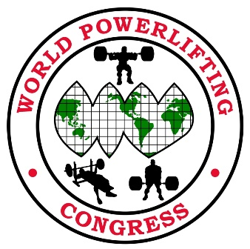
WPC AWPC EUROPEAN CUP - IRELAND 2023
COMPETITOR’S NAME | POWERLIFTING (PL)  BENCH (BP)  DEADLIFT (DL) | MULTI PLY (MP)  SINGLE PLY (SP)  CLASSIC RAW (CR)  RAW (R) | WEIGHT  CLASS | DOB + AGE |  | Open Teen Junior Master | FEE
 |  |  |  |  | Total

⚫ Lifters entry fees
Full Powerlifting = €100 Single lift Benchpress = €100 Single-lift Deadlift = €100
If doing two or more additional events first entry = €100 & all other entries after = €50 per entry.
lifters entering both Junior/Open or Master/Open same applies entry fee €100 + €50
ENTRY CLOSING DATE: Saturday April 1st 2023
This is strictly the deadline there will be no late entries after this date!
International team entries to be emailed to Irishpowerliftingorganisation@yahoo.com

Lifters from none affiliated european countries can also enter by paying individual WPC AWPC membership.
International team entry forms also available on WPC website.
http://www.worldpowerliftingcongress.com

⚫ All International entries will be only accepted from your WPC affiliated country head.

Payment can be made by bank transfer to the correct & full amount!

Please leave message stating country affiliation when making payment.

Payment Details

Beneficiary Bank: Permanent tsb.

Beneficiary Bank Address: University Court, Castletroy Limerick, Ireland.

Beneficiary Name: Irish Powerlifting Organisation.

BIC: IPBSIE2D
IBAN: IE39IPBS99072624025542

