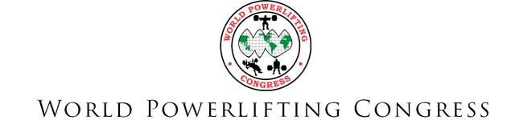

2023 AWPC Worlds & AWPC CanAm - Raw & Equipped – August 4-6

Meet Director: | Garry Frank 225-453-6073, 15836 Chivre Ave Greenwell Springs LA 70739 bulldogbr@bellsouth.net
Events: | Powerlifting (SQ+BP+DL), Bench Press only, Deadlift only
Official Hotel  & Meet Venue: | Embassy Suites Baton Rouge - 4914 Constitution Ave, Baton Rouge LA (225) 924-6566 Call for Special Rate of $120/night, mention AWPC Worlds (225) 924-6566
Lifting Sessions: | Lifting Sessions start 10:00 a.m. each day. Rules Clinic at 9:00 a.m. each day.
 | --> Days may be split into sessions based on entries after the deadline
 | Friday, August 4 – Raw Male & Female PL-BP-DL & Special Olympics
 | Saturday, August 5 – Classic Raw Male & Female PL (no BP-DL)
 | Sunday, August 6 – Equipped Male & Female (single & multi ply) PL-BP-DL
Eligibility: | US Lifters need to have placed 1st -3rd at AAPF Nationals May 26-28 at 2XL Powerlifting in Lombard, IL. US lifters must have current AAPF membership. International lifters need to qualify through their home country WPC Affiliate. Each country will need to provide the WPC Office a team list. See Country team roster.
Sanction/Rules: | Sanctioned by the Amateur World Powerlifting Congress. Check  http://worldpowerliftingcongress.com/ for official rules.  All lifters will be subject to random drug testing (minimum 10% of all lifters).
Equipment: | Categories included: Raw--belt/wrist wraps only, Classic Raw--knee sleeves/wraps included, Equipped Single Ply, and Equipped Multi Ply.
Weigh-ins: | Friday Lifters - Thursday, August 3: 10-11:30 a.m., 3-4:30 p.m. - @ Embassy Suites
 | Saturday Lifters - Friday, August 4: 10-11:30 a.m., 3-4:30 p.m. - @ Embassy Suites
 | Sunday Lifters - Saturday, August 5: 10-11:30 a.m., 3-4:30 p.m. - @ Embassy Suites
 | All lifters must weigh-in the day before they compete--no morning of weigh-ins
Entry Fee: | An entry fee of $125 US is required for all lifters. Lifters wanting to enter multiple divisions will need to pay a $50 US fee for each additional division.
 | Competitors may have to lift on multiple days if they choose to compete in multiple events and/or divisions. NO REFUNDS.
Confirmation & | US Lifters must confirm their spot by June 15 with the APF Office. Entry deadline is
Deadline: | July 1, 2023. Late entries that are accepted will be charged $25 late fee.
 | International WPC Affiliates need to confirm their team list no later than July 1.
Awards: | Custom Medals will be given to the first three places in all categories. Best Lifter Awards will be given in categories based on the content of the entries.

2023 AWPC Worlds & AWPC CanAm Entry - Mail this page w/entry fee to:
Garry Frank 15836 Chivre Ave, Greenwell Springs, LA 70739
Make Checks/Money Orders Payable to: Garry Frank
USA Lifters AWPC Worlds must place in top 3 at AAPF Nationals

In consideration of the acceptance of this entry thereby for myself, my heirs, executors, and administrators waive and release any and all claims and damages I may have against the APF/AAPF, WPC/AWPC, Garry Frank, Hardcore Barbell, Embassy Suites Baton Rouge, their representatives, successors, and assigns for any and all injuries or bodily harm that I may suffer while competing at the 2023 AWPC Worlds. I attest and verify that I have full knowledge of the risks involved with my participation in this event, and that to the best of my knowledge I am physically fit and able to participate in this event. I understand there is random drug testing by urinalysis on a minimum of 10% of all lifters. AAPF policy permanently bans any lifter testing positive for a banned substance.

Signature: _____________________________________________________ Date: _______________

Parent/Guardian (if under 18): _____________________________________ Date: ________________

Print Name: ___________________________________________________

Address: _____________________________________________ City: _________________________

State: ________ Zip Code: ____________________ Phone: (_________)_______________________

Email: _____________________________________________________________ Sex: _____________

Date of Birth: ____________ Age : __________ Gym/Team: _________________________________

Occupation / Interesting Facts: __________________________________________________________
Circle Category: AWPC Worlds AWPC CanAm  Circle Event(s):  Powerlifting Bench Press only Deadlift only  Circle Equipment:  Raw Classic Raw EQ Single Ply EQ Multi Ply  Raw is belt/wrist wraps only, Classic Raw includes knee sleeves/wraps.  Circle Weight Class:  Men: 114, 123, 132, 148, 165, 181, 198, 220, 242, 275, 308, SHW  52 56 60 67.5 75 82.5 90 100 110 125 140 140+  Women: 97, 105, 114, 123, 132, 148, 165, 181, 198, 220, 242, Unl  44 48 52 56 60 67.5 75 82.5 90 100 110 110+  Circle Division(s) Entered:  Teen 13-15, 16-17, 18-19, Junior 20-23, Open, Submaster 33-39, | Total Amount Enclosed  Entry Fee:  _$125__  Division Crossover: _($50)_  Official Meet T-shirt (limited shirts available day of meet)  _($25-$30)_  Size: _______  2X-3X $30  Late Fee after 7/1: _($30)_  Total: ______
Master 40-44, 45-49, 50-54, 55-59, 60-64, 65-69, 70-74, 75-79, 80+

COUNTRY:
CONTACT PERSON:
EMAIL:
TEL NUMBER:
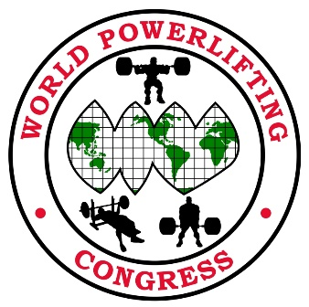
2023 AWPC World Championships
Baton Rouge, Louisiana USA

COMPETITOR’S NAME | POWERLIFTING (PL)  BENCH (BP)  DEADLIFT (DL) | MULTI PLY (MP)  SINGLE PLY (SP)  CLASSIC RAW (CR)  RAW (R) | WEIGHT  CLASS | DOB + AGE |  | Open Teen Junior Master | FEE | AWPC or  CanAm
 |  |  |  |  | Total

Send Country Team list to amyljackson@aol.com
Individual entries will not be accepted

