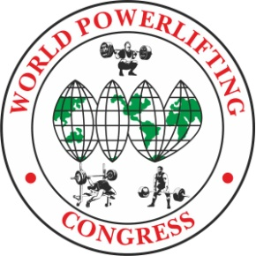
Yuriy Ustinov
Meet Director, President WPC-RUSSIA
wpcwpo@gmail.com
+7-918-947-04-62

WORLD CUP WPC/AWPC- 2023
in POWERLIFTING, BENCHPRESS & DEADLIFT

Location: Hotel Resort “Flamingo”
Oleg Koshevoy str.19, Divnomorskoe, Gelendzhik, Russia, 353490

Meet Director: Yuriy Ustinov, WPC Russia President.

Dates: 23-24 September, 2023
Lifting Schedule: 24 September – AWPC – All
25 September – WPC - All

Weigh-In Schedule: 23 September - Weighing the participants of the first day.
24 September - Weighing the participants of the second day.

Categories: All AWPC/WPC Weight Categories & All AWPC/WPC Age Divisions
Raw, Classic Raw, Single-ply and Multi-ply

Entry Fees: First Event WPC $70
Additional Events S50 per event

First Event AWPC $100
Additional Events $50 per event

Closing Date: 23th August, 2023. Team List must reach the Meet Director by this date, otherwise late entry fees will apply. Each nation must set their own closing dates for lifters to submit their entry for inclusion on the team list.

To Enter: Applications are accepted through the national offices of the WPC. If it
doesn't exist, then do it yourself. Write to wpcwpo@gmail.com

Entry list: www.wpc-wpo.ru https://fb.me/e/3YUnhNETH

Websites: All information will be included on the championships website:

https://powertable.ru/api/hs/p/fed?fed=77&lg=en
www.wpc-wpo.ru

Visas: To get all the necessary information about a visa support to Russia use this link: www.visatorussia.com
Please take care of your visa in advance!

Hotel: Competitions will be held in the sports complex resort Hotel Flamingo
https://flamingo.one/
office@flamingo.one

$40 Single Room FB (Full board) per day
$65 Dbl Room FB (Full board) per day
The city and its surroundings are the best resort in Russia. In September, the
weather is very comfortable:
air + 26 + 29 C.
sea ​​water +25.
Airports nearby:
Sochi - 200 km.
Mineralnye Vody – 500 km
We will help you organize an inexpensive transfer of teams. wpcwpo@gmail.com

Rules: These Championships will be conducted using the AWPC/WPC Rules. The Rulebook is available to download from the WPC Website https://worldpowerliftingcongress.com/

Referees: Applications for refereeing from the referee of the international category WPC to the e-mail address are accepted: wpcwpo@gmail.com

Welcome to Russia. Welcome to Resort.

