Yuriy Ustinov
WPC-RUSSIA President
wpcwpo@gmail.com
+7-918-947-04-62

WPC/AWPC World Cup Moscow 2023
in POWERLIFTING, BENCH PRESS, DEADLIFT

Location: Location: Moscow, 2- Reisovaya ulitsa 2. 119027
DoubleTree by Hilton Moscow – Vnukovo Airport Hotel

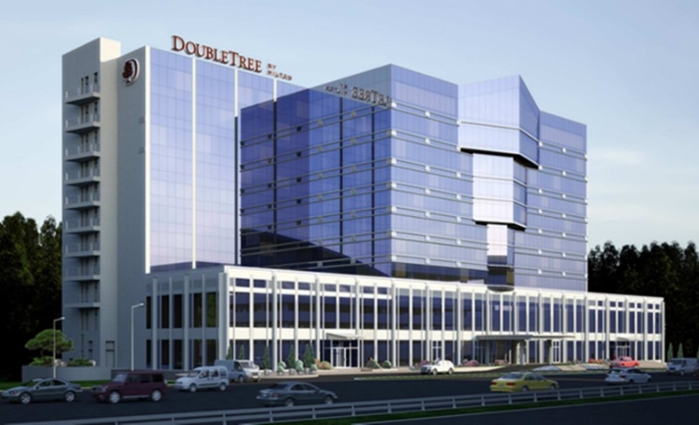

Meet Director: Yuriy Ustinov, WPC Russia President.

Dates: 03 December 2023
Lifting Schedule: 03 December 2023 – All Lifts

Weigh-In Schedule: 02 December 2023 - Weighing the all participants.

Help of a translator. For the convenience of athletes, a WhatsApp support chat with an English-speaking specialist will be opened.
You can ask any questions and receive advice on your journey and tournament.
To add to the chat, you need to send a request to WhatsApp +79189470462

Categories: Powerlifting, Bench Press and Dead Lift
Age Divisions
Raw, Classic, Single Ply and Multiply

Entry Fees: First Event WPC $80
Additional Events $40 per event

First Event AWPC $95
Additional Events $40 per event

All payments - on weighing. There are no prepayments.

Closing Date: 15 October 2023. Team List must reach the Meet Director by this date. Each nation must set their own closing dates for lifters to submit their entry for inclusion on the team list.

To Enter: Entry list:
https://powertable.ru/api/hs/p/fed?fed=80&lg=en
To make an application on participation please by email: wpcwpo@gmail.com

Entry fees: on the venue.

Websites: All information will be included on the championships website: https://powertable.ru/api/hs/p/fed?fed=80&lg=en
Contact e-mail: wpcwpo@gmail.com WhatsApp +79189470462

Visas: To get all the necessary information about a visa support to Russia use this link: www.visatorussia.com
Please take care of your visa in advance!

Hotel: Location: Moscow, 2- Reisovaya ulitsa 2. 119027
DoubleTree by Hilton Moscow – Vnukovo Airport Hotel
Rules: These Championships will be conducted using the WPC Rules. The Rulebook is available to download from the WPC Website https://worldpowerliftingcongress.com/

Airports nearby:
Sheremetyevo - 55 km. free shuttle to Hotel.
Domodedovo- 40 km.
Vnukovo – 0 km.

Referees: Applications for refereeing from the referee of the international category WPC to the e-mail address are accepted: wpcwpo@gmail.com

Welcome to Russia!

