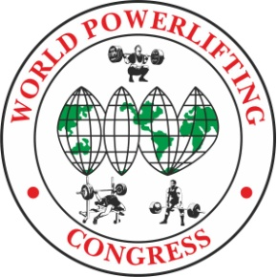
Yuriy Ustinov
Meet Director, President WPC-RUSSIA
wpcwpo@gmail.com
WhatsApp +7-918-947-04-62

OPEN EUROPEAN CUP WPC/AWPC- 2024
in POWERLIFTING, BENCHPRESS & DEADLIFT

Location: Russia
Moscow, Mezhdunarodnoye Shosse, 28B, p. 5
Sheraton Sky Lux Moscow Sheremetyevo Airport Hotel
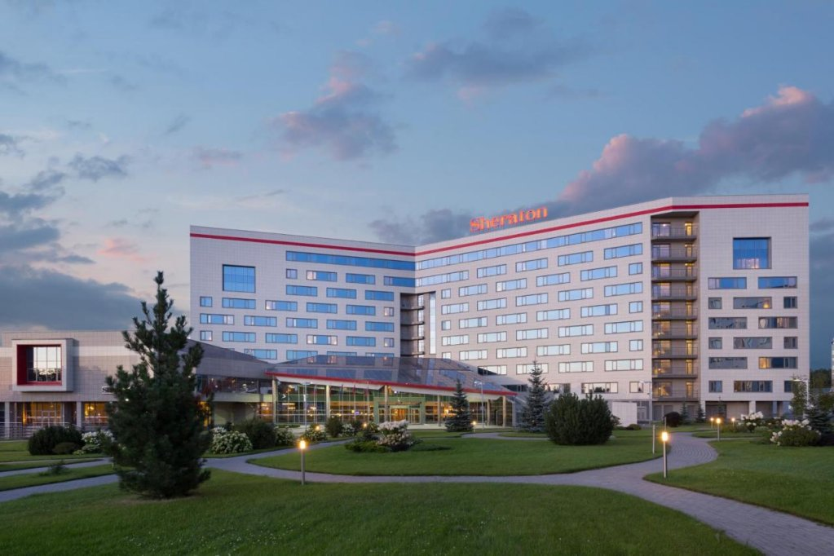

Meet Director: Yuriy Ustinov, WPC Russia President.

Dates: 06-07 July, 2024
Lifting and
Weigh-In Schedule: Will be later.

Categories: All AWPC/WPC Weight Categories & All AWPC/WPC Age Divisions
Raw, Classic Raw, Single-ply and Multiply

Entry Fees: First Event WPC $85
Additional Events S35 per event

First Event AWPC $100
Additional Events $35 per event

Late Entry Fees – no penalty

Closing Date: 10th June, 2024. Team List must reach the Meet Director by this date, otherwise late entry fees will apply. Each nation must set their own closing dates for lifters to submit their entry for inclusion on the team list.

To Enter: To apply, you must contact your WPC Country Head. If there is no one, then write
directly to the organizers: wpcwpo@gmail.com
There are no upfront fees. All payments are on the spot.

Help of a translator. For the convenience of athletes, a WhatsApp support chat with an English-
speaking specialist will be opened.
You can ask any questions and receive advice on your journey and tournament.
To add to the chat, you need to send a request to WhatsApp +79189470462

Websites: All information will be included on the championships website:

http://powertable.ru/api/hs/p/fed?fed=80&lg=en www.wpc-wpo.ru

Visas: To get all the necessary information about a visa support to Russia use this link: www.visatorussia.com
Please take care of your visa in advance!

Hotel: https://sheratonsvo.ru/ http://en.skypoint-hotel.ru/

Airports nearby: Sheremetyevo SVO
Free shuttle bus from SVO in Hotel.

Rules: These Championships will be conducted using the AWPC/WPC Rules. The Rulebook is available to download from the WPC Website https://worldpowerliftingcongress.com/

Referees: Applications for refereeing from the referee of the international category WPC to the e-mail address are accepted: wpcwpo@gmail.com

Welcome to Russia.

