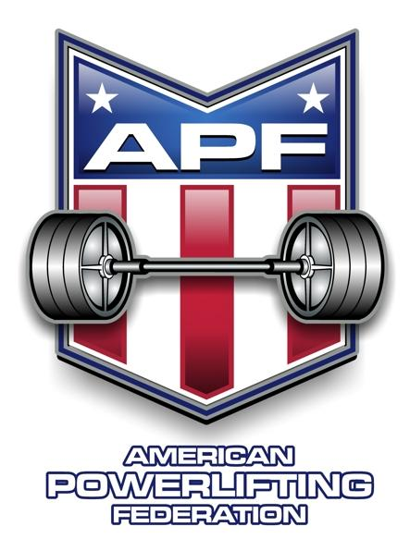
APF St Landry Cajun Classic
October 12th 2024

Sponsored By: Hardcore Barbell , Baton Rouge, LA.

Meet Director: Garry Frank-11490 Joor Road, Baton Rouge LA 70818
225-453-6073

Sanctioned By: APF – American Powerlifting Federation

Eligibility: Lifters must be APF registered you can register online
www.worldpowerliftingcongress.com

Meet Site: St Landry Barbell, 6760 LA-31 Opelousas LA

Lifting Session: Saturday October 12th 10:00 am All lifters

Weigh-in: At Meet Venue Friday October 11th
10 am to noon, 6pm to 8pm
Saturday October 12th 8:00am to 9:00am

Contest Lifts: Squat, Bench Press, & Dead Lift or
Bench Press Only or Dead Lift Only

Entry Fee: $90 full meet $100 late entry $90 bench only
$60 add a division $90 dead lift only
$80 team (11 lifters) $50 APF card $30 teen APF card

Entry Deadline: Entries must be received by September 1st to avoid late fee

Weight Classes: Men: 114,123,132,148,165,181,198,220,242,275,308,SHW
Women: 97, 105, 114,123, 132, 148, 165, 181, 198, 220, 242, UNL

Awards: 1st -3rd per weight class (open, teen, women, novice, junior (20-23), Masters (40-44), (45-49), etc…

Best Lifter Awards for Open, Master, Bench Only and Women

Glossbrenner Formula used to determine best lifter.

Make checks payable to Garry Frank 11490 Joor Road, Baton Rouge LA 70818
Call 225-453-6073

NAME:___________________________________________________________

Address:_________________________________________________________

City:________________________________State:________Zip:___________

Date of birth:__________________ Age:___________

APF card #:_________________ Expiration Date:________________

Phone #:___________________ Email:________________________________

Entry Fee Required For Each Division Entered

Equipped Multi Ply□ Single Ply□ Classic Raw□ Raw□

Weight Class____________ Male□ Female□

Full meet□ Bench only□ Dead lift only□

Masters_____ Open_____ Teen_____ Jr_____

WAIVER
In consideration of the acceptance of this entry I hereby for myself, my heirs, executors, and administrators waive and release any and all rights and claims for damages I may have against the APF, WPC, Garry Frank, Hardcore Barbell South, St Landry Barbell their representatives, successors and assigns for any and all injuries or bodily harm that I may suffer while competing at the 2024 APF St Landry Cajun Classic.

_______________________________________
Please sign first and last name here
(Parent signature required if athlete under age 18)

