**APF/AAPF National Powerlifting Championship**

**Start Date:** **Wednesday, June 11, 2025**

**End Date:** **Sunday, June 15, 2025**

**Hotel(s) offering your special group rate:**

**Fairfield Inn & Suites Detroit Troy**

**225 Stephenson Hwy, Troy, MI 48083**

**149.00 USD per night**- **Last Day to Book :Wednesday, May 21, 2025**

**l**

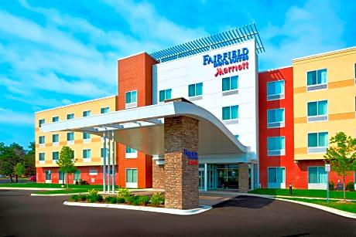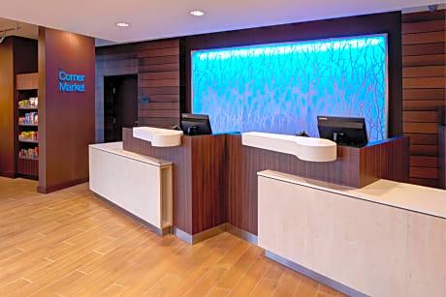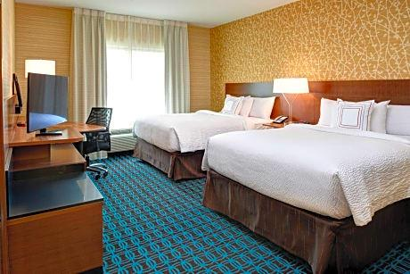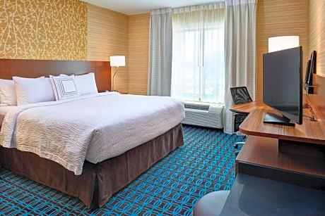

(Hotel is 5 minutes from meet venue Royal Oak Gym on the same road)

**APF/ AAPF National Powerlifting Championship**

**Start Date:** **Wednesday, June 11, 2025**

**End Date:** **Sunday, June 15, 2025**

**Hotel offering your special group rate:**

**TownePlace Suites Detroit Troy**

**325 Stephenson Hwy, Troy, MI 48083**

**149.00 USD per night**- **Last Day to Book :Wednesday, May 21, 2025**

[**Book your group rate for National Powerlifting Championship**](https://www.marriott.com/event-reservations/reservation-link.mi?id=1739033906594&key=GRP&guestreslink2=true&app=resvlink)

**Or call** 248-585-7000 **and make sure mention the meet for the special rate**

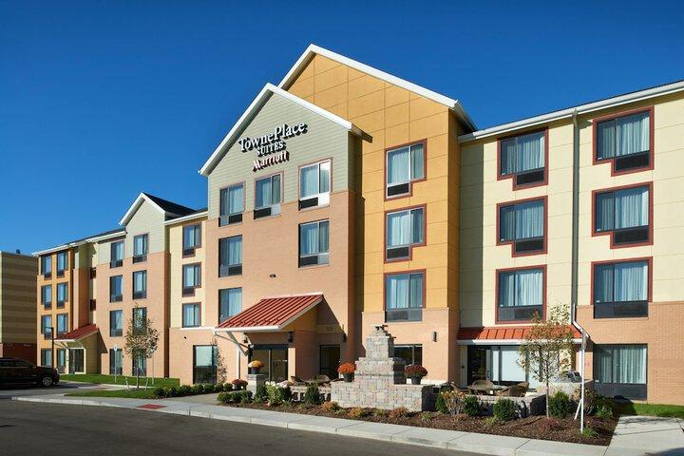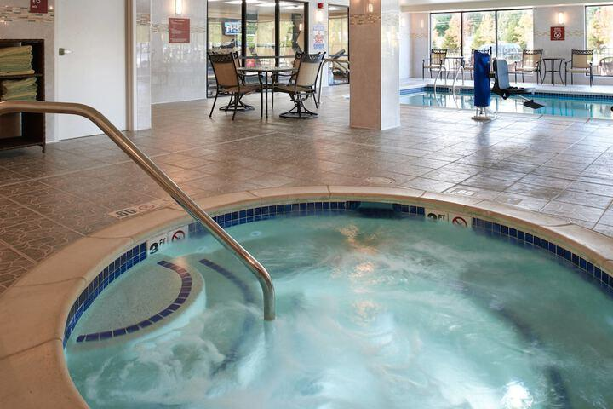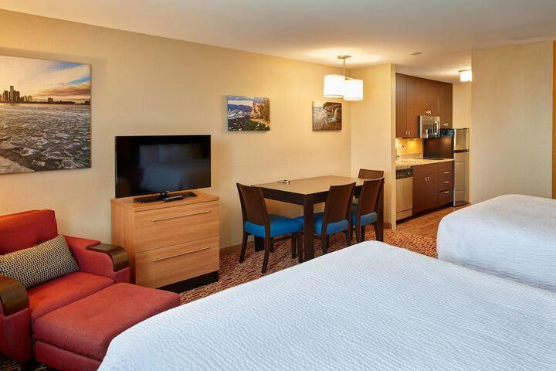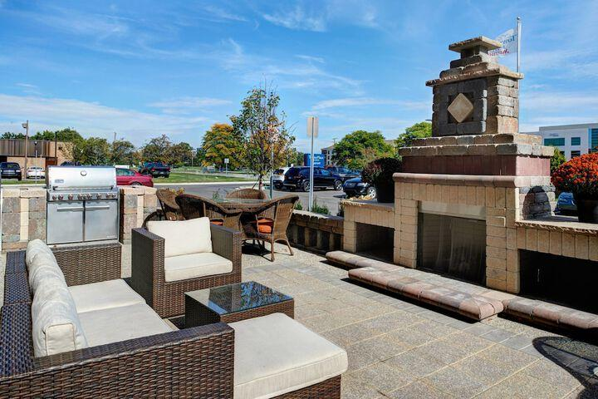

(Hotel is 5 minutes from meet venue Royal Oak Gym on the same road)