APF-AAPF Lifting Spirits Annual Invitational (60 Lifter Cap)
Dec. 6th, 2025
Meet proceeds support two local children’s organizations.

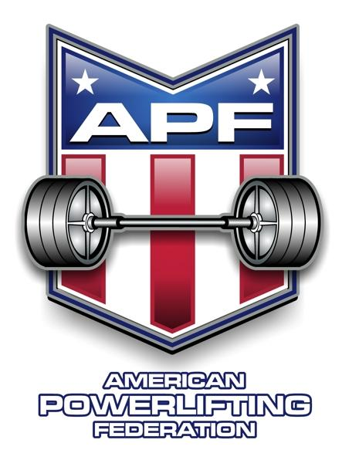

Meet Director: Mike Denmon
MikeDenmon1@gmail.com (409) 960-2505

SANCTIONED BY: APF/AAPF

EVENT LOCATION: Orange County Convention and Expo Center
11475 FM 1442 Orange, TX 77630
(409) 745-9712

ELIGIBILITY: Lifters must be an APF/AAPF registered athlete by the time of the meet. You can renew or get your new membership at www.worldpowerliftingcongress.com.

WEIGH-IN: Friday, Dec.5th, 2025: 9:15am – 12:00pm and 4:00pm – 7:00pm
The weigh-ins will be conducted at the Expo Center.

Saturday, Dec. 6th, 2025: 7:00am – 8:00am
The weigh-ins will be conducted at the Expo Center.

EVENT: MANDATORY RULES BRIEFING: Saturday, Dec. 6th, at 8:30 am
Lifting starts at 9:15am.

UNIFORM: One-piece lifting suit or wrestling suit is MANDATORY.

CONTEST LIFTS: Full Meet (Squat/Bench/Deadlift), Bench Only, Deadlift Only

ENTRY FEE: Meet entry fee is $100 if received on or prior to Nov. 10, 2025. If received after this date, there is an additional $25 late fee. Additional divisions are $25 each. PayPal, Venmo, Cash App or money order. Make money orders payable to Mike Denmon.

Equipment Platform and warm-up area will have custom monolifts, 30kg/66lb squat bars,25kg/55lb bench bars, 20kg/44lb deadlift bars, plus multiple 45lb bars and competition benches.

NOTES:
- No spectator fee….lunch and snacks will be provided at no additional charge to all. Any donations will go toward the two organizations we will be working with. It won’t be diet food, so if you’re watching calories you should plan for that. Water and drinks will be provided as well.

APF-AAPF Lifting Spirits Annual Invitational (60 Lifter Cap)
Dec. 6th, 2025
Meet proceeds support two local children’s organizations.

Please Print Legibly

Full name: ___________________________________________________________________ Sex (circle one): Male Female
Age ____________ Date of Birth ____________________________ e-mail ___________________________________________
Address ___________________________________________________________________________________________________
City ___________________________________________ State ___________________ Zip Code ___________________________
Phone Number ____________________________________ Alternate Phone Number _____________________________________
Current APF/AAPF card (circle one): No Yes If so, card number is _______________________________________________

APF AAPF (circle one)
Event Entered (circle all that apply): Full Meet Bench Only Deadlift Only
Raw/Equipped (circle one): Raw Classic Raw Single Ply Multi Ply Unlimited Shirt
Division Entered (circle all that apply): Open
Police/Fire
Teen: 13-15 16-17 18-19
Junior: 20-23
Submaster: 33-39
Master: 40-44 45-49 50-54 55-59 60-64 65-69 70-74
75-79 80+
Weight Class (circle one): Women: 97 105 114 123 132 148 165 181 198 220 242 242+ (UNL)
Men: 114 123 132 148 165 181 198 220 242 275 308 308+ (SHW)

Fees & Payment: Entry fee $100: _______
PayPal.Me/CrossTrainers1, Additional divisions $25 each: _______
Venmo-Mike Denmon @crossTrainers1. Total:______
Cash App-Mike Denmon $Crosstrainers1.
Email your entry form to MikeDenmon1@gmail.com if using payment methods above.
Make checks or money orders out to: Mike Denmon

ATHLETIC RELEASE: On behalf of myself, my heirs, executors, administrators, and assigns, I hereby waive, release, and fully discharge any and all officials, sponsors, participants, or organizations connected to the Texas APF/AAPF, Mike and Lee Denmon, from any and all rights, claims, demands, lawsuits, and causes of action due to or arising from any accident, injury, damage, or loss directly, indirectly, or in any way associated with my participation in the APF/AAPF Lifting Spirits Strength Invitational, Dec. 6th, 2025. I also represent that I know of no medical reason or condition that would impair my ability to participate in this event, and I hereby assume any and all risk of accidental, medical injury or consequential damages resulting from my participation. I acknowledge, understand, and accept the inherent risk of powerlifting. I have read the above release, understand its meaning and consequence, and agree to be legally bound by its terms. I have signed this release freely and voluntarily.

__________________________________________ ____________________________________________
Print Full Name Lifter’s signature
(Parent must sign if lifter is under 18 years of age.)

If paying by check or money order, mail with hard copy entry form to: Mike Denmon
PO Box 1422
Mauriceville, TX 77626

