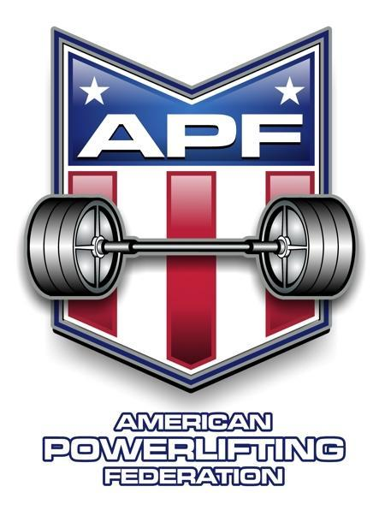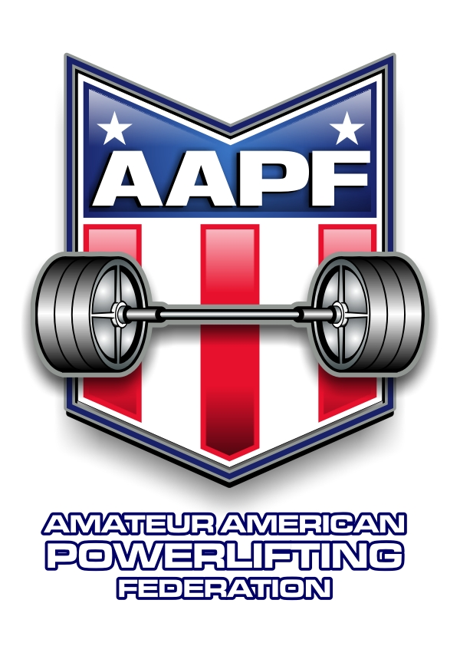
APF -AAPF Big Dog Barbell Georgia State Championship

Sponsored By: Big Dog Barbell Strength Training for Special Needs a registered 501(c)(3) nonprofit
(EIN: 92-1347790)

Meet Director: Catalina Duran, 770-561-5639, catalina.duran.bdb@gmail.com

Sanctioned By: APF – American Powerlifting Federation/AAPF - Amateur American Powerlifting Federation

Eligibility: Lifters must be APF /AAPF member you can register online
www.worldpowerliftingcongress.com
Check qualifications requirements online

Meet Site: TitanForce Strength 5735 N Commerce Ct, Unit E, Alpharetta, GA

Lifting Session: Saturday March 13th 9:30 am

Weigh-in: All weigh-ins will be at the meet venue day before you compete (24 hr. weigh-in rule applies)
Friday March 12th 10am-11:30 am, 4pm to 6pm

Contest Lifts: PL: Squat, Bench Press, Deadlift or
BP: Bench Press Only or DL: Deadlift Only

Entry Fee: $100 full meet $100 bench only $100 deadlift only $80 teen entry
$50 add a division $50 late entry $50 novice
Membership $50 APF or AAPF $60 for both Teenage ½ price

Entry Deadline: Entries must be received by February 1st to avoid late fee

Weight Classes: Men: 114,123,132,148,165,181,198,220,242,275,308, SHW
Women: 97, 105, 114,123, 132, 148, 165, 181, 198, 220, 242, UNL

Awards: 1st -3rd per weight class / category

Best Lifter Awards based on content of entries Glossbrenner Formula used to determine best lifter.

This meet will be a qualifier for APF – AAPF Nationals

APF -AAPF Big Dog Barbell Georgia State Championship
This meet will be a qualifier for APF – AAPF Nationals

Please Print Legibly

Full name: ___________________________________________________________________ Gender: (Circle one) Male Female
Age ____________ Date of Birth ____________________________ e-mail ___________________________________________
Address _________________________________________City_______________________State _________ Zip Code _________
Phone _________________________________________ Alternate Phone Number _____________________________________
See www.worldpowerliftingcongress.com for complete rules on raw/classic raw/equip categories
Category Entered (circle all that apply): APF AAPF (tested) Novice
Event Entered (circle all that apply): Full Meet Bench Only Bench Only Unlimited Shirts Deadlift Only
Raw/Classic Raw/Equipped (circle all that apply): Raw Classic Raw Single Ply Multi Ply

Division Entered (circle all that apply): Special Olympics
Police/Fire/Military
Open
Teen: 13-15 16-17 18-19
Junior: 20-23
Submaster: 33-39 (no Submaster at WPC Worlds)
Master: 40-44 45-49 50-54 55-59 60-64 65-69 70-74
75-79 80-84 85-89
Weight Class (circle one): Women: 97 105 114 123 132 148 165 181 198 220 242 Unl
Men: 114 123 132 148 165 181 198 220 242 275 308 308+

Fees & Payment: Entry fee $100: __________
Make checks or money orders payable to Big Dog Barbell, 3115 Westshore Dr, Cumming, GA 30041
Paypal: Big.Dog.Barbell23@gmail.com If after February 1, 2027, add late fee $50: __________

Additional divisions $50 each: __________
T-Shirts pre-orders $30
S M L XL 2X 3X (circle order) T-Shirts $30 each: __________

TOTAL DUE: __________
ATHLETIC RELEASE: On behalf of myself, my heirs, executors, administrators and assigns, I hereby waive, release and fully discharge any and all officials, sponsors, participants or organizations connected to the APF, the WPC, Big Dog Barbell, Inc., Joshua Porter, Catalina Duran, TItanForce Strength, Quentin White, Thomas Mathers, the APF/AAPF, their respective officers, directors, employees, agents and shareholders, of and from any and all rights, claims, demands, lawsuits, and causes of action due to or arising from any accident, injury, damage or loss directly, indirectly, or in any way associated with my participation in the APF-AAPF Nationals, June 7-9, 2024 I, also, represent that I know of no medical reason or condition that would impair my ability to participate in this event, and I hereby assume any and all risk of accidental, medical injury or consequential damages resulting from my participation. I acknowledge, understand and accept the inherent risk of powerlifting. I have read the above release, understand its meaning and consequence, and agree to be legally bound by its terms. I have signed this release freely and voluntarily.

___________________________________________ ____________________________________________
Lifter’s signature (Parent must sign if Lifter is under 18 years of age)

