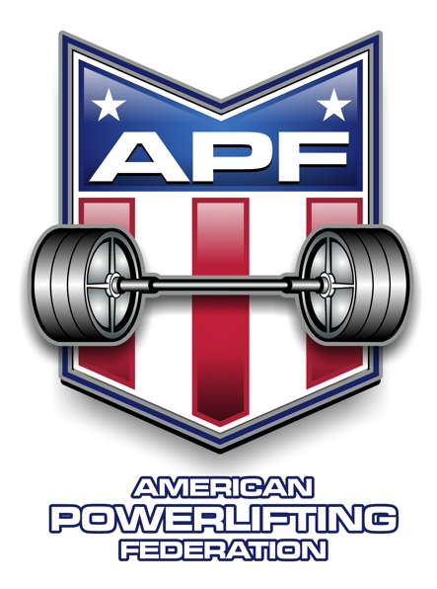
505 Westgate Drive, Aurora, IL 60506
630-896-7309 1-866-389-4744
www.worldpowerliftingcongress.com

APF-AAPF Membership Application
(on-line registration)

Name:
Address:
City, State, Zip:
Home Phone:
Work Phone:
Cell Phone:
E-mail address:
Date of Birth:
Age:
Sex:
US Citizen:
Registration: APF $30 or AAPF $30 or Both $40
Date of Application:

