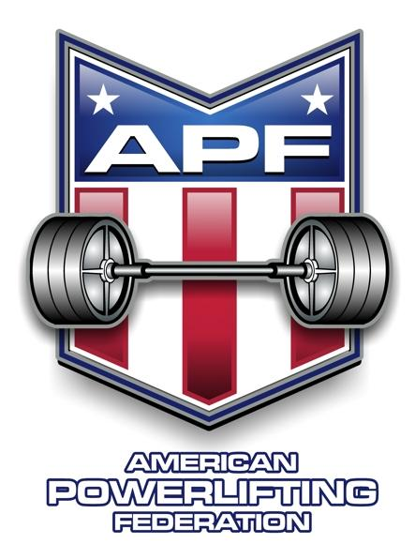
2015 APF Louisiana Powerlifting
Bench Press & Dead Lift Championships

Sponsored By: Hardcore Barbell South, Central, LA.

Meet Director: Garry Frank-15836 Chivre Avenue
Greenwell Springs, LA. 70739

Sanctioned By: APF – American Powerlifting Federation

Eligibility: Lifters must be APF registered
(lifters may register on meet day)

Meet Site: Days Inn, 10455 Reiger Road, Baton Rouge, LA. 70814
1-225-293-6880

Lifting Session: Saturday, March 28, 2015 10:00 am All lifters

Weigh-in: Friday, March 27, 2015: 10 am to noon, 6pm to 8pm
Saturday, March 28, 2015: 8:00am to 9:00am

Contest Lifts: Squat, Bench Press, & Dead Lift or
Bench Press Only or Dead Lift Only

Entry Fee: $75 full meet $85 late entry $75 bench only
$50 add a division $75 dead lift only $5 guest fee
$80 team (11 lifters) $30 APF card $15 teen APF card

Weight Classes: Men: 114,123,132,148,165,181,198,220,242,275,308,SHW
Women: 97,105,114,123,132,148,165,181,198,SHW

Awards: 1st -3rd per weight class (open, teen, women, novice, junior (20-23), Masters (40-44), (45-49), etc…
Best Lifter Awards for Open, Master, Bench Only and Women

Glossbrenner Formula used to determine best lifter.

Make checks payable to Garry Frank*15836 Chivre Avenue,
Greenwell Springs, LA. 70739
Call 225-241-8154 if information needed for hotel rooms.

NAME:___________________________________________________

Address:__________________________________________________

City:________________________________State:________Zip:___________

Date of birth:___________ Age:___________

APF card #:_________________ Expiration Date:________________

Phone #:___________________ Email:_________________________

Entry Fee Required For Each Division Entered
Equipped□ Single Ply□ Raw □ Weight Class____________
Full meet□ Bench only□ Dead lift only□

Masters_____ Open_____ Teen_____ Jr_____
Male□ Female□

WAIVER
In consideration of the acceptance of this entry I hereby for myself, my heirs, executors, and administrators waive and release any and all rights and claims for damages I may have against the APF, WPC, Garry Frank, his heirs, Hardcore Barbell South, their representatives, successors and assigns for any and all injuries or bodily harm that I may suffer while competing at the 2015 APF Louisiana State Powerlifting, Bench, & Deadlift Championships.

_______________________________________
Please sign first and last name here
(Parent signature required if athlete under age 18)

