09/07/09

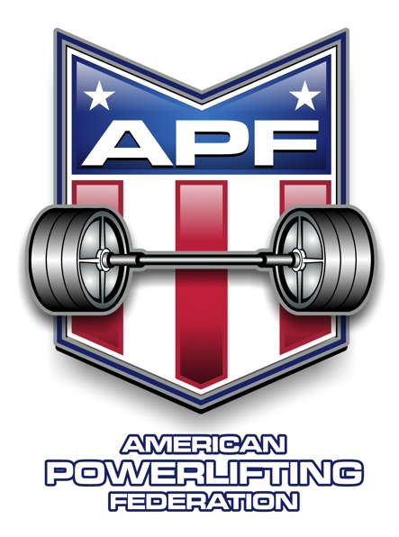

To all USA based APF and WPC referees, thank you for your continued involvement in and support of our federation. The sacrifices you make to fill the role are not overlooked, and your contributions are appreciated.

Collectively our referees perform consistently with rule requirements. Due to federation growth and personnel turnover though there are some areas needing improvement. On our WPC website in the APF-WPC forum under the Powerlifting section there is currently and will continue to be new information pertinent to judging. Some is just for information, some is or will be educational, and it includes some new requirements. Please take the time to familiarize yourself with the information, and then periodically review for updates.

Please send questions and comments to Amy Jackson as the focal point for processing.

Respectfully,
APF Executive Committee

